
Tesla Coil Project Report
February 26, 2016

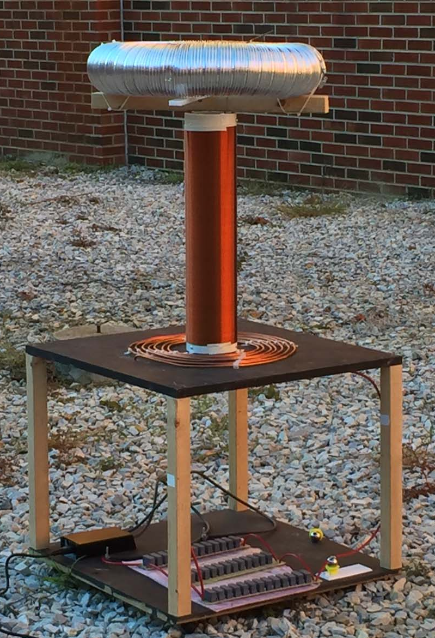
Team Lead: Matthew Castleberry
Team Members: Murphy Braswell, Ben Brotzman, Jonathan Brown, Travis Keller, Josh Jablonowski, Joseph McCrary, Mike Petry, Gavin Prather, Steven Sinakhot

Project Initiation Date: 9/24/15
Project Overview:
As a demonstration for Auburn's E-Day, built a full size tesla coil. A tesla coil acts as a giant voltage transformer that can generate arcs of electricity into the air. Nicola Tesla invented and built the first tesla coils. His intentions were to create wireless energy. While tesla coils do in fact create a strong electromagnetic field, they are not ideal for practical applications. The intent of this project is to learn concepts about electricity and magnetism and demonstrate them to the community.
How it Works:
There are two different types of tesla coils: spark gap and solid state. Nicola Tesla built spark gap tesla coils. A spark gap tesla coil works by using a high voltage transformer that then charges a capacitor. The capacitor then discharges across a small gap of air hence the spark gap. This creates a resonating square wave of high voltage that then is conducted through a primary coil. The primary coil inducts through electromagnetism into the secondary coil. Charge builds up in the air around the toroid and creates an arc of electricity.
Our Progress:
The goal is to develop a tesla coil that can shoot out arcs of lengths up to 3 feet. Our long term goal is to create a musical tesla coil. Basically it produce arcs in the resonance and rhythm as preprogrammed music. We decided to divide the project into three sections: miniature spark gap tesla coil, large spark gap tesla coil, and large musical solid state tesla coil. We completed the miniature tesla coil and it works as designed and generates an arc length of about 2 cm. From there we have constructed a full scale tesla coil using a 7530 volt transformer. The Tesla Coil creates arcs up to 6" thus creating approximately 400,000 volts of electricity. Some future work on the spark gap Tesla Coil would be increasing the size of capacitors by using fabricating capacitors out of raw material.
Schematics:
- Spark Gap Circuit
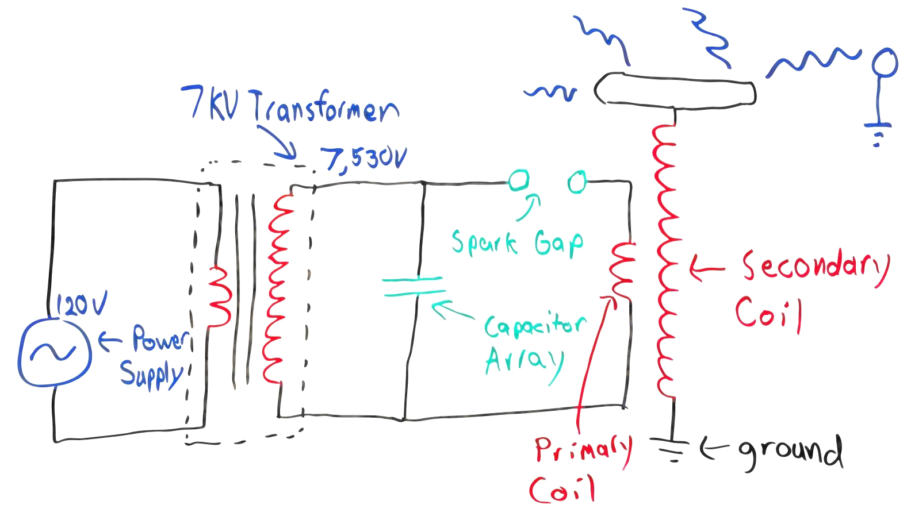
- Capacitor Array
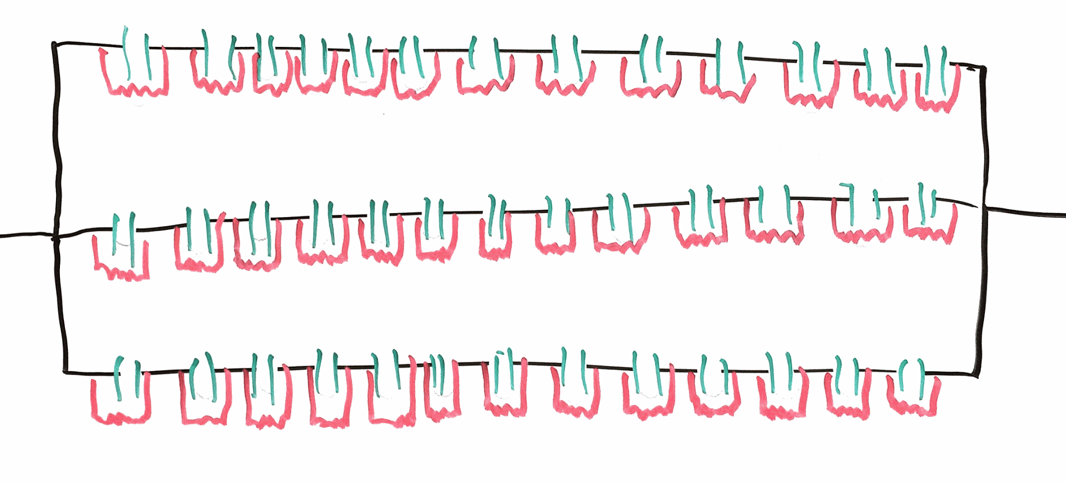
- Solid State Musical Tesla Coil

Specifications:
Sub Assembly | Specification | Number | Unit
Power | Output Voltage | 7,530 | Volts
 | Output Current | 35 | mA
 | Output Power | 263.55 | Watts
Capacitor | Net Capacitance | 0.0157 | micro F
 | Individual Cap | 0.068 | micro F
 | Array | 3 x 13
Spark Gap | radius of electrode | 0.5 | inches
 | distance between | 0.25 | inches
Primary Coil | Turns | 15
 | radius inner | 3.75 | inches
 | radius outer | 11.25 | inches
 | length | 58.88 | feet
 | Radius between | 0.296 | inches
 | Inductance | 87.684 | micro H
 | Diameter of wire | 0.2 | inches
Secondary Coil | Turns | 1508
 | radius | 2.27 | inches
 | Height | 21.81 | inches
 | Diameter | 28 | AWG
 | Frequency | 135 | Hz
Toroid | radius inner | 3.25 | inches
 | radius outer | 10.5 | inches
Photos of Operation:
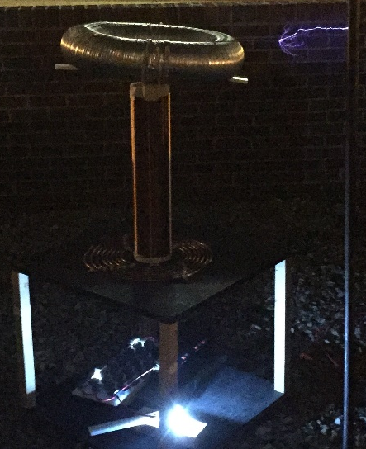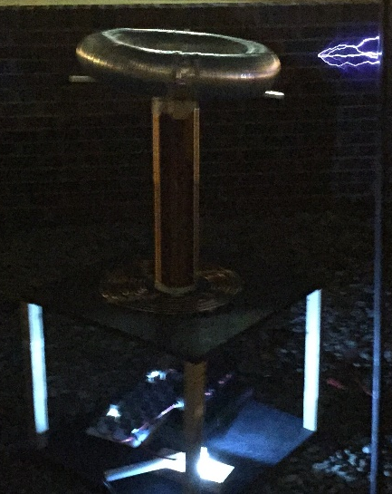

Sources:
Inspiration: https://www.youtube.com/watch?v=fdIYwIWfYyo
Miniature Tesla Coil: https://www.youtube.com/watch?v=qUKYCRhXFgo
Small Scale Example: https://onetesla.com/
How Tesla Coils Work: http://www.realclearscience.com/articles/2014/01/29/how_tesla_coils_work_108474.html
List of Tesla Coil Formulas: http://teslacoils4christ.org/TCFormulas/TCFormulas.htm
How to make a Musical Tesla Coil: http://www.instructables.com/id/Build-a-Musical-Tesla-Coil-like-a-Pro/
MMC Capacitor: http://deepfriedneon.com/tesla_f_mmc.html

